**APYTHONPROGRAMTOIMPLEMENTADABOOSTING**

**Ex.No.:8 Date of Submission:11/10/2024**

**AIM:-**

To implement a python program for Ada Boosting.

# ALGORITHM:-

Step1: Import the necessary libraries(pandas as pd, numpy as np and plot_decision_regions from mlxtend.plotting)

Step2: Create a dataframe and fill values and labels in the data frame and display it. Step3: Import seaborn as sns and plot a scatter plot with the data frame components as the parameters.

Step4: Add a new component to the data frame called “weights” which equals the inverse of the cumulative dimensions of the data frame and display it.

Step5: Import “DecisionTreeClassifier” from sklearn.tree and create an object.

Step6: Assign the variables “x” and “y” the range of values from the data frame.

Step7: Fit the first tree and then plot the tree using “plot_tree” imported from sklearn.tree.

Step8: Plot the decision regions using the above trained tree as the classifier.

Step9: Introduce a new component in the dataframe called “y_pred” to store the values predicted by the above use decision tree and display the decision tree.

Step10: Create a function which returns half the values of log of (1-error)/(error) and calculate the weight of the decision tree.

Step11: Create a function to update the weights of the instances such that the weight is multiplied by exp(-alpha) if correctly classified and multiplied by exp(alpha) if misclassified. Step12: Create a new component of the data frame called ”updated_weights” and apply the created function on the columns in the data frame and store the resulting values in the new component and display the data frame.

Step13: Add all the values in the “updated_weights” component and add a new component called “normalized_weights” which equals the division of each individual instance value by the sum of values of all instances and display the updated data frame.

Step14: Calculate the sum of the values of the “normalized_values” component and display it.

Step15: Add a new component called “cumsum_upper” the cumulative sum of the ”normalized_weights” values.

Step16: Add another component called “cumsum_lower” which is the difference between the

“cumsum_upper” and “normalized_weights” and display all the components of the data frame . Step17: Follow the above 16 steps two more times for 2 new data frames and 2 new decision trees(second_df,third_df,dt2and dt3 respectively)

Step18: Compare the predicted values of all the decision trees.

Step19: Multiply alpha1, alpha2 and alpha3 by 1 and add all the values.

Step20: Find the sign of the resulting values from the previous step.

Step21: Multiply alpha1 by1, alpha2 and alpha3 by -1 and add the values and find the sign of the resulting value.

# IMPLEMENTATION:-

import pandas as pd import numpy as np

from mlxtend.plotting import plot_decision_regions

df = pd.DataFrame()

df['X1']=[1,2,3,4,5,6,6,7,9,9] df['X2']=[5,3,6,8,1,9,5,8,9,2] df['label']=[1,1,0,1,0,1,0,1,0,0]

df

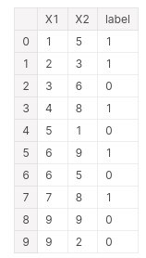

import seaborn as sns

sns.scatterplot(x=df['X1'],y=df['X2'],hue=df['label'])

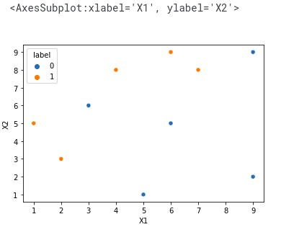

df['weights']=1/df.shape[0]

df

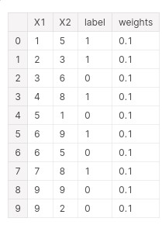

from sklearn.tree import DecisionTreeClassifier

dt1 = DecisionTreeClassifier(max_depth=1)

x = df.iloc[:,0:2].values y = df.iloc[:,2].values

# Step 2 - Train 1st Model

dt1.fit(x,y)



from sklearn.tree import plot_tree

plot_tree(dt1)

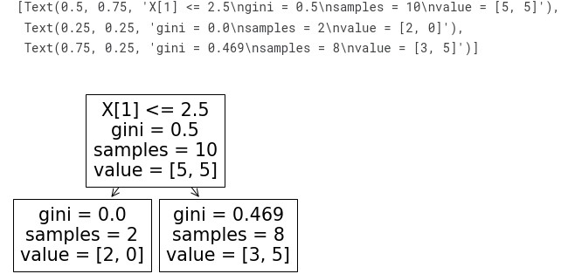

plot_decision_regions(x,y,clf=dt1,legend=2)

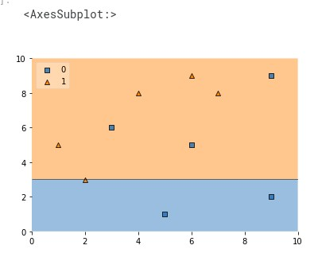

df['y_pred'] = dt1.predict(x)

df

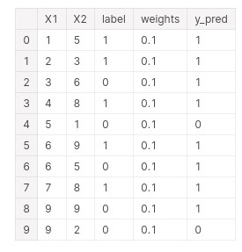

def calculate_model_weight(error):

return 0.5*np.log((1-error)/(error))

# Step - 3 Calculate model weight alpha1 = calculate_model_weight(0.3) alpha1



# Step -4 Update weights def update_row_weights(row,alpha=0.423): if row['label'] == row['y_pred']:

return row['weights']* np.exp(-alpha)

else: return row['weights']* np.exp(alpha)

df['updated_weights'] = df.apply(update_row_weights,axis=1) df

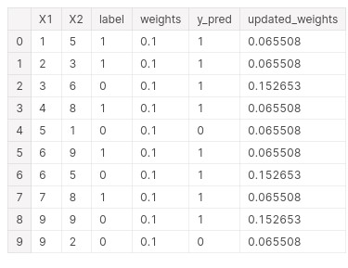

df['updated_weights'].sum()



df['normalized_weights']=df['updated_weights']/df['updated_weights'].sum()

df

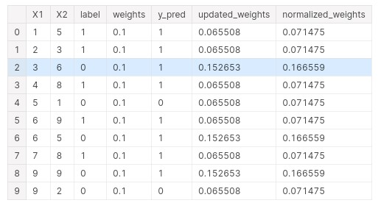

df['normalized_weights'].sum()



df['cumsum_upper'] = np.cumsum(df['normalized_weights'])

df['cumsum_lower']=df['cumsum_upper'] - df['normalized_weights']

df[['X1','X2','label','weights','y_pred','updated_weights','cumsum_lower','cumsum_upper']]

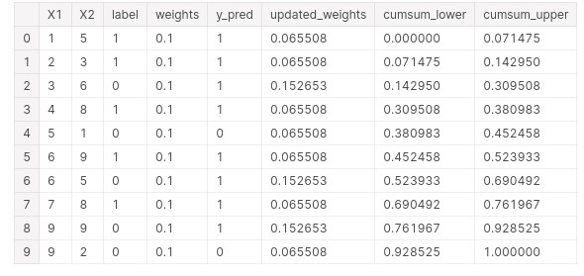

def create_new_dataset(df): indices= [] for i in range(df.shape[0]): a = np.random.random() for index,row in df.iterrows():

if row['cumsum_upper']>a and a>row['cumsum_lower']:

indices.append(index)

return indices

index_values = create_new_dataset(df) index_values

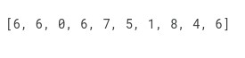

second_df = df.iloc[index_values,[0,1,2,3]]

second_df

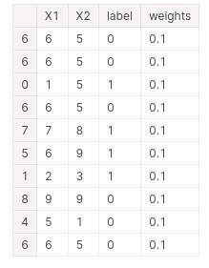

dt2 = DecisionTreeClassifier(max_depth=1)

x = second_df.iloc[:,0:2].values y = second_df.iloc[:,2].values

dt2.fit(x,y)



plot_tree(dt2)

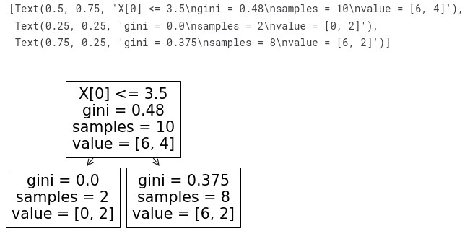

plot_decision_regions(x, y, clf=dt2, legend=2)

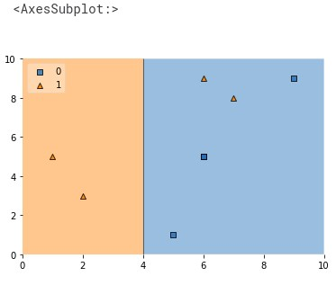

second_df['y_pred'] = dt2.predict(x)

second_df

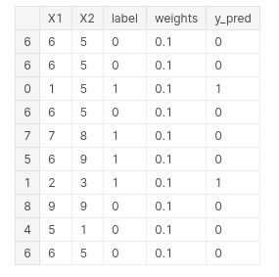

alpha2 = calculate_model_weight(0.1)

alpha2



# Step 4 - Update weights def update_row_weights(row,alpha=1.09): if row['label'] == row['y_pred']:

return row['weights'] * np.exp(-alpha)

else: return row['weights'] * np.exp(alpha)

second_df['updated_weights'] = second_df.apply(update_row_weights,axis=1)

second_df

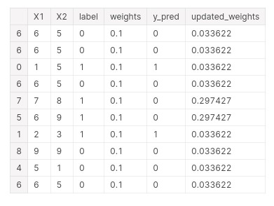

second_df['nomalized_weights'].sum()



second_df['cumsum_upper'] = np.cumsum(second_df['nomalized_weights'])

second_df['cumsum_lower'] = second_df['cumsum_upper'] - second_df['nomalized_weights'] second_df[['X1','X2','label','weights','y_pred','nomalized_weights','cumsum_lower','cumsum_upp

er']]

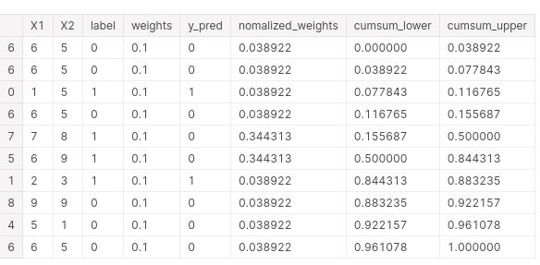

index_values = create_new_dataset(second_df) third_df = second_df.iloc[index_values,[0,1,2,3]] third_df

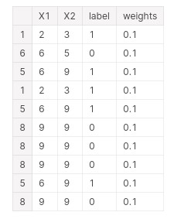

dt3 = DecisionTreeClassifier(max_depth=1)

X = second_df.iloc[:,0:2].values

y = second_df.iloc[:,2].values dt3.fit(X,y)



plot_decision_regions(X, y, clf=dt3, legend=2)

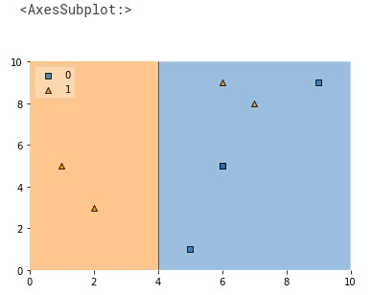

third_df[‘y_pred] = dt3.predict(X)

third_df



alpha3 = calculate_model_weight(0.7) alpha3



print(alpha1,alpha2,alpha3)



query = np.array([1,5]).reshape(1,2) dt1.predict(query)



dt2.predict(query)



dt3.predict(query)



alpha1*1 + alpha2*(1) + alpha3*(1)



np.sign(1.09)



query = np.array([9,9]).reshape(1,2) dt1.predict(query)



dt2.predict(query)



dt3.predict(query)



alpha1*(1) + alpha2*(-1) + alpha3*(-1)



np.sign(-0.25)



# RESULT:-

Thus the python program to implement Adaboosting has been executed successfully and the results have been verified and analyzed.